CS 255 Business Requirements Document

System Components and Design

Purpose
- DriverPass is the client. The aim is to help students pass DMV tests with online practice and real driving time.
- Build a cloud-based web system that students and staff can open on any computer or phone.
- Offer online classes and practice tests, let students book two-hour lessons, and let staff manage accounts and packages.
- Give leadership easy reports and an activity log that shows who created, changed, or canceled items.
- Let staff export reports to Excel for offline review but require an online connection for any data edits.

System Background
- Problem. Many students fail DMV tests because they do not know the rules well and do not get enough practice.
- Solution. Provide online learning and practice tests, plus in car training with two-hour sessions and simple packages.
- Users and roles. Owner, IT officer, secretary, instructors, and students. Each role has the right level of access. IT can reset and block accounts.
- Scheduling. Track the student, instructor, car, date, start time, and end time. Prevent double booking and keep a full change history.
- Current content. Receive DMV updates for rules and sample questions and notify staff when something changes.
- From the sketch. Show online test progress with test name, time taken, score, and status. Show student info fields, driver notes with lesson times, a special needs field, and photos for the driver and the student.

Objectives and Goals
- The system will let a new student create an account, log in, and reset a forgotten password without staff help.
- The system will present DMV style practice tests and record test name, time taken, score, and status as not taken, in progress, failed, or passed.
- The system will show online test progress and lesson history on the student page in a layout that matches the sketch.
- The system will let a student schedule, change, or cancel a two-hour lesson and will block conflicts for the instructor or the car.
- The system will let the secretary create, change, or cancel any student reservation through an admin screen.
- The system will assign each lesson to one instructor and one car and store lesson time, start hour, end hour, and instructor comments.
- The system will store and display student profile data, special needs, and photos for both the student and the driver.
- The system will support multiple training packages and let staff disable a package for new signups without deleting past records.
- The system will keep an activity log that records who created, modified, or canceled each reservation and will allow printing of an activity report.
- The system will allow IT admin users to reset passwords and block or unblock employee accounts.
- The system will accept DMV updates or allow staff to load updates, so course content stays current.
- The system will run in a desktop and mobile browser and load normal pages in a reasonable time for daily use.
- The schedule aligns with the transcript plan and will be shown in a Gantt chart.

Requirements

Nonfunctional Requirements

Performance Requirements
- Web based, responsive in a modern browser.
- Pages load within 2–3 seconds under normal traffic.
- Common actions like login, booking, and viewing scores complete in under 2 seconds.
- Practice tests save answers as you go to avoid data loss.
- Content updates and small fixes can be deployed with near zero downtime.

Platform Constraints
- Runs on a cloud hosted web stack.
- Works on current versions of Chrome, Edge, Safari, and Firefox.
- Mobile friendly for iOS and Android browsers.
- Uses a managed database for reliability and backups.
- Uses a third party email and SMS service for notifications.

Accuracy and Precision
- Unique usernames or verified emails identify users.
- Inputs like names, addresses, and payment details are validated on the client and server.
- Booking rules enforce two hour lessons and prevent double booking a driver or car.
- Activity logs record who created, changed, or canceled a booking with timestamps.

Adaptability
- Roles and permissions can be changed by IT without code changes.
- Owner can enable or disable lesson packages from the admin area.
- DMV content can be refreshed by an import job or API without redeploying the site.
- The system can grow to support more cars, drivers, and locations later.

Security
- All traffic is over HTTPS.
- Passwords are hashed and never stored in plain text.
- Brute force protection locks an account after repeated failed logins and alerts IT.
- Students can reset forgotten passwords through a secure email or SMS flow.
- Admin actions are audited in a read only log.
- Payment is handled by a certified payment gateway. No card data is stored on our servers.
- Regular backups run daily with a tested restore process.

Functional Requirements
- The system shall validate user credentials and assign the correct role at sign in.
- The system shall let users create accounts, update profiles, and reset passwords.
- The system shall let students view packages, enroll, and pay through a third party gateway.
- The system shall schedule a two hour lesson with chosen date, time, driver, and car, and prevent double booking.
- The system shall let students or the secretary modify or cancel lessons within policy.
- The system shall capture pickup and drop off locations for each lesson.
- The system shall record driver notes and show lesson history to the student.
- The system shall provide online classes and practice tests and store scores and status.
- The system shall send confirmations and status updates by email or text.
- The system shall let the owner enable or disable packages.
- The system shall receive DMV content updates and flag new rules or questions.
- The system shall log who created, changed, or canceled each reservation and generate activity reports.
- The system shall let the IT officer manage users and roles.
- The system shall export selected reports to CSV or Excel.

User Interface
- Runs in a browser on desktop and mobile. No install needed.
- Clear menus for Classes, Practice Tests, Lessons, Profile, and Help.
- Students can register, log in, view progress, take practice tests, book lessons, change or cancel lessons, and view driver notes.
- Secretary can search students, create and change bookings, view driver schedules, and print activity reports.
- Instructors can see assigned lessons, log start and end times, and enter lesson notes.
- Owner can view reports, enable or disable packages, and review activity logs.
- IT officer can manage users and roles and handle locked or forgotten accounts.
- Forms validate entries and show plain error messages.
- Pages match the owner sketch for test progress and lesson tables.

Assumptions
- Staff and students have internet access and a modern browser.
- DMV provides a usable feed or files for rule and question updates.
- A payment gateway account is available and set up by DriverPass.
- Lesson policy for cancel and reschedule is provided by DriverPass.
- Driver and car availability is maintained by staff and kept current.
- Email and SMS providers are available for notifications.

Limitations
- Version one supports one location and a fixed two hour lesson length.
- Custom package building by non technical staff is out of scope.
- No offline editing. Data changes require an online connection.
- Integration depends on DMV update access and payment gateway uptime.
- Budget and team size may limit advanced analytics in the first release.
- External email and SMS delivery times can vary.

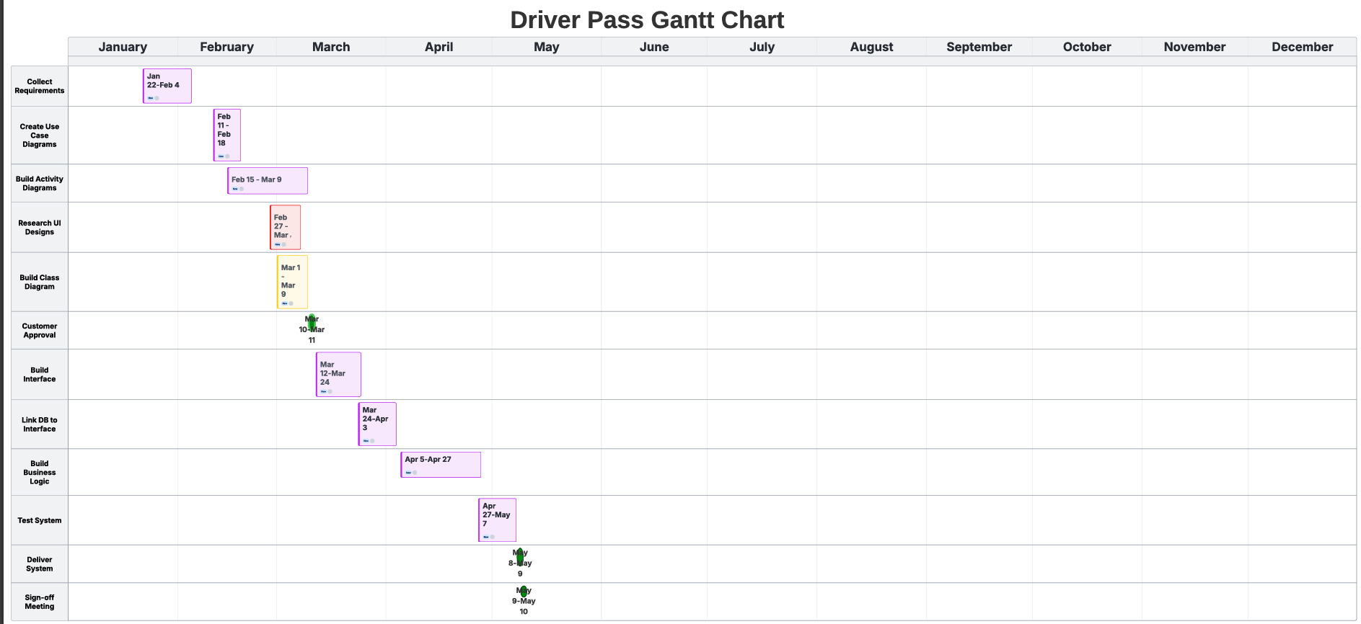
Gantt Chart

